
The Catholic Community of
St. Francis of Assisi

Finance Council Minutes
Date: 8/10/26 Time: 7:00 p.m.

Attendance:
Members | Present | Members | Present | Members | Present | Members | Present
Steve Vebber | X | Sarah Hoffman | X | Rob Neppel | X | Fr. Chris Koehn | X
 |  | Reji John | X | Esperanza Neri | X | Fr. James Singarayar | X
Sean Bragg | X | Steve Joseph | X | Luke O’Rourke | X
Lachlan Cox | X | Arvie Lacson | X | Clare Pope | X | Tina Subasic | X
Graham Dixon | X | Nancy Martinez |  | Peter Russo | X
Paul Fedorkowicz | X | Nancy McElroy | X | Aaron Stutzman
Heidi Hobler | X | Mike Misko | X | Bob Weisenberger | X

AGENDA:
Opening Prayer
Welcome, (Council Picture)
Chair Announcements
Accept Minutes of 6/1/26
Review Term Schedule
School Updates – TFS & Pre-School
Summary of 2025-2026 YE Closings
2Q 2026 Endowment Status
Maintenance Reserve/Project Update
Q&A
Meeting Schedule for 2026-27 Fiscal Year
Closing Prayer

ANNOUNCEMENTS:
  - Steve Vebber led the meeting.
  - Nancy McElroy was introduced to the Council She is the new Principal of TFS. Also introduced was Tina Subasic, who is the new Parish Council Chair. Welcome to both
  - Steve announced that the Franciscan VIA (Values in Action) led by Mary Ellen McGuire, Director of Justice and Peace, is launching this fall. This is a parish wide initiative to help parishioners to live out the Franciscan values through service, peace and justice. It is open to all and will meet monthly to bring people together and share their ministry experiences and strengthen the connection across the Ministries. The initial gathering is set for September 24th at 6pm.
  - He also announced the Elevated Parish Mission. This is a 3 night parish-wide event on October 25–27. The mission is intended to help parishioners encounter the transforming love of Jesus Christ, find deeper purpose, peace, hope, healing, and grow in the joy of discipleship. This will be introduced to the Parish, in the coming weeks.
  - The Jubilee Mass was held at the Cathedral this week and was well attended. Also, there is 3 part video on the Diocese website which is a walking tour of this campus that everyone is encouraged to view.
  - Fr. Chris and staff are working on a status report to be shared with the Parish on our current activities and how we are progressing against the goals and objectives of the Pastoral Plan.
  - SFA is considering several possible changes to the Sanctuary, including Installing a San Damiano Crucifix, moving the tabernacle to a more prominent location on the altar, relocating the presider’s chair, possibly behind the ambo. Parish leaders are asking members to reflect on these ideas and share any concerns or suggestions directly with Fr. Chris.
  - There will be a table at the Ministry Fair weekend representing the Finance Council and the Count Team. A chart of the volunteers was shown.
  - Also shared was the Finance Council members’ service terms and when they are eligible to retire. Steve Vebber, Sarah Hoffman, and Peter Russo have agreed to extend their terms.

OLD BUSINESS:
  - Steve Vebber requested feedback on the Finance Council Meeting Minutes of 6/1/26.
  - No additional changes were requested.
  - Vote Taken – A motion to approve the Finance Council Meeting Minutes of 6/1/26, was made and approved.

NEW BUSINESS:
School Updates:

TFS Update:
  - Nancy McElroy announced that current enrollment is at 653 versus a plan of 686. The Kindergarten class is at 65 vs a target of 72. There is still interest coming in for this year as well as for next year. Nancy noted that she wants to do more research to understand the reasons for this year’s enrollment decline and also revisit why some of the applicants were rejected.
  - As for staffing, we just hired a new Bridges lead. We have strong list of candidates for the School Nurse position which just opened. We are also working on the open positions for the Dean of Elementary Students and an ITA for 5th grade.

Pre-School Update:
  - Heidi Hobler noted that 164 students have registered for school year 2026-27. Our budget for this school year was built with an assumption of 166 students.
  - There are openings in the toddler class, 4 year old 4 day and the transitional class. The 3 year old classes are full. Before and After Care are well utilized.
  - The need for Tuition assistance continues to rise. The tithe money from the Church tithe and the funds from the Arelene Straight Endowment for this year, have all been awarded.
  - We are currently fully staffed for this school year.
  - This is the 35th year of the Pre-School. There will be a celebration in Apil. Details to follow.

FY 2025-2026 Closing Summary:
  - Rob Neppel reviewed the following charts which show how we finished the year out.
  - He noted that all our entities finished in a positive manner:

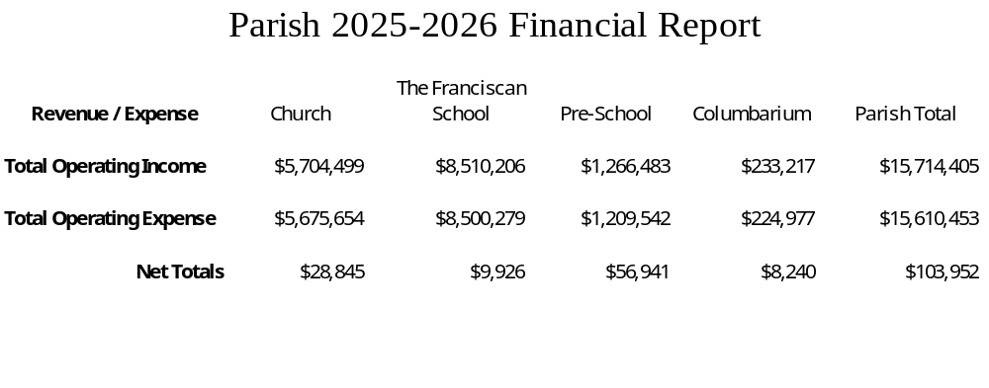

  - The following shows the balances in our checking, savings and endowment accounts:
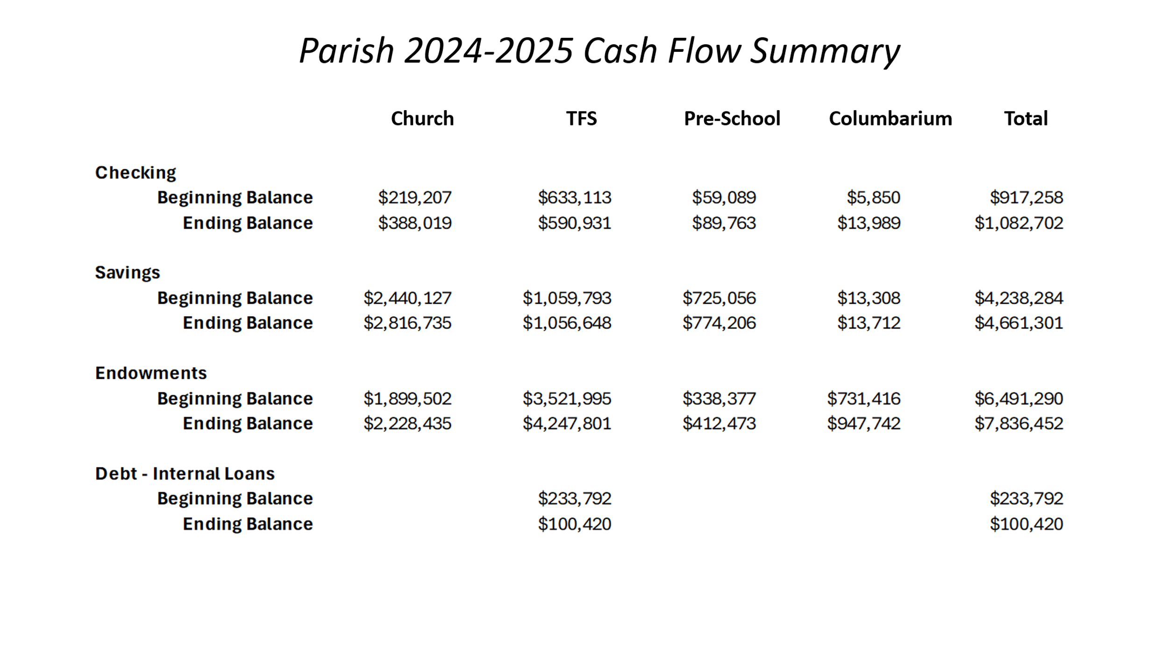

  - We made several transfers at yearend; This chart shows the transfers that were made:
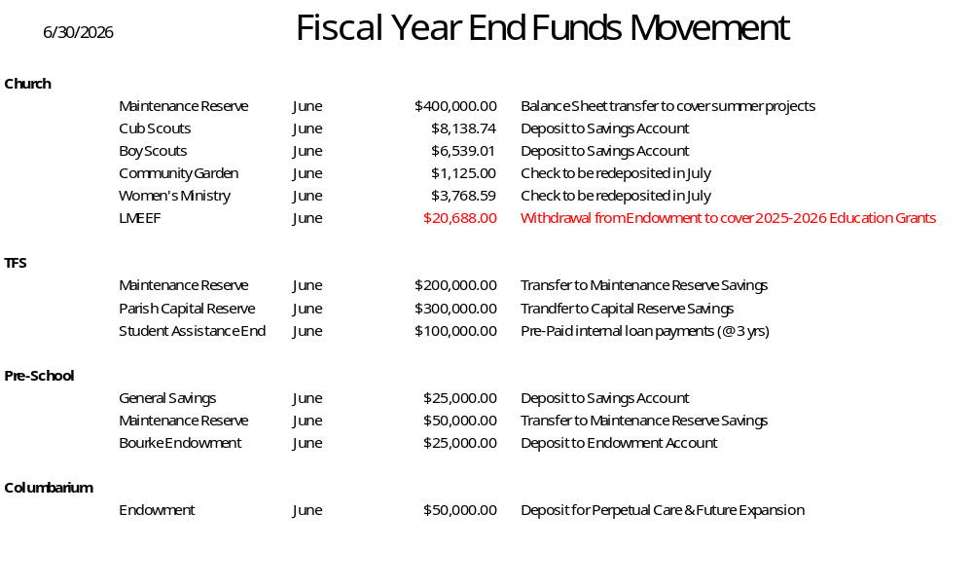

  - This shows the 6/30/26 balances of each entity’s savings accounts
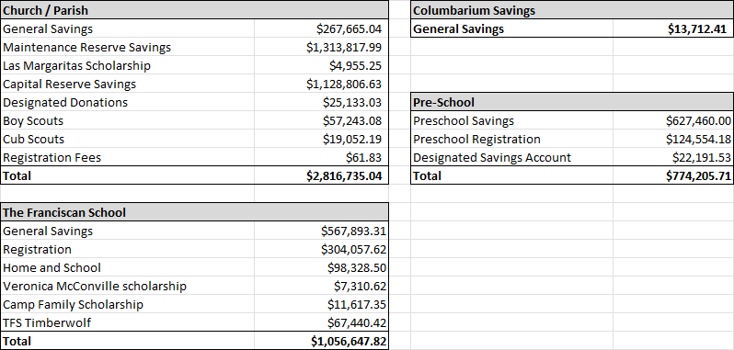

  - Note that In the month of July we made the following transfers into the 2026/27 Operational Budgets:
Church $400,000 - Balance Sheet Transfer for July Summer Projects.
TFS $295,2022 – Registration Fees designated for the 2026/27 School Year
Pre-School $119,649 – Registration Fees designated for the 2026/27 School Year
2Q 2026 Endowment Status:
  - Rob Neppel shared a detailed chart showing performance of all our endowments for the Second Quarter ending 6/30/26. This detail was included in the package sent to the Finance Council in Rob Neppel’s note of 8/7/26.
  - In summary, Endowment return for the Second Quarter was +8.6%. The total value of our Endowments is $7,836,452. The Corpus value is $3,692,925. Overall, it was a very strong Quarter.

Maintenance Update:
  - Rob Neppel noted that it was a very busy here at the Parish the last few months. He provided a status of our Spring/Summer Projects:

- Replace Anthony Hall & Gathering Space Carpet Complete
- Renovate TFS (Thea Hall) Bathrooms Complete
- Preschool (Clare Hall) Security Enhancements Complete
- Paint Exterior of TFS Quad Buildings Complete
- Paint Interior of Bonaventure Complete
- Replace Covered Walkway Pillars Complete
- Replaced Clare Preschool & Kitchen HVAC System Complete
- Resurface TFS Courtyard Benches with Trex Complete
- Added Security Lighting for Elizabeth Hall Complete
- Shade Structures added to Preschool Playground Complete
- Added New Mulch to Playgrounds Complete
- New Sound System in Gym Complete
- Workshop Renovation Complete
- Replaced ATV Complete
- School Network Isolation On-Going
- Added Security Gates to TFS Parking Lot On-Going
- Upgrading all Exterior Door Locks On-Going
- Refinish Pews As Schedule Allows

Note the pews are being done by Fr. Dan Kenna’s brother at a minimal charge to the Parish.

  - Parish Maintenance Reserve - Projected Balance:

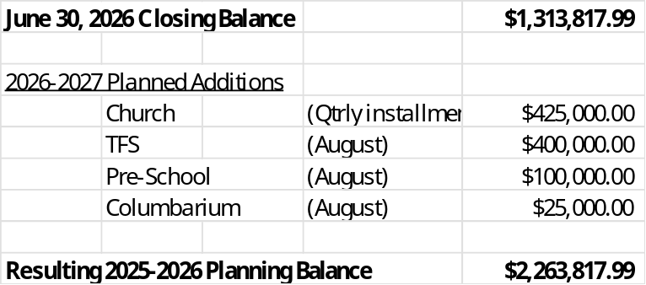

* Note that this does not include the Maintenance Sunday contributions.

  - The Maintenance Oversight Committee will meet on September 10th to discuss and recommend projects for the Fall and Winter. Their recommendations will be presented to the Finance Council at the October 5th scheduled meeting.
  - Some of the Pending Projects they will review include:
- Renovate remaining Rectory Bathroom
- Replace Phase V & Siena Building Roofs
- Paint Church Interior
- Refinish side of Church Steps
- Ongoing Security Enhancement
- Ongoing Heat Pump Replacements
- San Damiano Renovations
- Repave Church Parking Lot (we have been resealing, but that will not suffice now)

- Potential Additional Solar Array (Gym) – Not a Maintenance Project

  - Tina Subasic said that she knows an individual that is knowledgeable of recycled/sustainability alternatives if the committee needs assistance exploring.

VOTES TAKEN:
  - A motion to approve the Finance Council Meeting Minutes of 6/1/26, was made and approved.

OTHER:
  - Father Chris approved all the recommendations and votes taken during this Council meeting.
  - He said he was excited about the Franciscan Values in Action and the Elevated Parish Missions that were discussed earlier in the meeting. Both will renew the parish spirit and will have many other long term beneficial effects on the Parish.

FUTURE MEETINGS:
  - Schedule for Fiscal Year 2026-27 Finance Council Meetings – All meetings start at 7:00 p.m. on Mondays.
Monday – October 5, 2026 - Fall / Winter Maintenance Projects
Monday – November 16, 2026 - Approve School Tuition Rates
Monday – January 11, 2027 - Mid-Year Checkpoint
Monday – March 8, 2027 - Spring / Summer Maintenance Projects
Monday – April 26, 2027 - Approve School Budgets
Monday – May 24, 2027 - Approve Church & Columbarium Budgets

