
The Catholic Community of
St. Francis of Assisi

Finance Council Minutes
Date: 6/1/26 Time: 7:00 p.m.

Attendance:
Members | Present | Members | Present | Members | Present | Members | Present
Steve Vebber | X | Sarah Hoffman | X | Esperanza Neri | X | Fr. Chris Koehn | X
 |  | Reji John | X | Luke O’Rourke | X | Fr. James Singarayar
Sean Bragg | X | Steve Joseph |  | Clare Pope | X | Fr. Joseph Ita-Sam
Lachlan Cox | X | Arvie Lacson | X | Peter Russo | X | Mae Villanueva | X
Graham Dixon |  | Nancy Martinez | X | Aaron Stutzman | X
Paul Fedorkowicz | X | Mike Misko | X | Bob Weisenberger | X
Heidi Hobler | X | Rob Neppel | X

AGENDA:
Opening Prayer
Chair Announcements
Accept Minutes of 4/27/26
School Updates – TFS & Pre-School
Presentation of 2026-2027 Church & Columbarium Budgets
Church – vote to be taken
Columbarium – vote to be taken
Offertory Update
Closing the Books on 2025-26
Q&A
Meeting Schedule for 2026-27 Fiscal Year
Closing Prayer

ANNOUNCEMENTS:
  - Steve Vebber led the meeting.
  - Father Joseph will be moving on to work at the Diocese as an assistant to the Bishop. There will be celebrations after the masses on the weekend of June 13/14th (except after the 11:45 Sunday mass).
  - Mae Villanueva announced that that there will be a mass to celebrate the jubilee year(800th) of St. Francis on August 5th at Holy Name of Jesus Cathedral at 6:30 pm. All are invited.
  - It was also announced that this will be the last Finance Council Mae will be attending as she is stepping down as Chair of the Parish Council. Thank you for your service, Mae.

OLD BUSINESS:
  - Steve Vebber requested feedback on the Finance Council Meeting Minutes of 4/27/26.
  - No additional changes were requested.
  - Vote Taken – A motion to approve the Finance Council Meeting Minutes of 4/27/26, was made and approved.
NEW BUSINESS:
School Updates:

TFS Update:
  - Father Chris provided background information to the Council on recent developments at TFS.
  - Rob Neppel noted that as of the meeting, there are 657 students that have enrolled for the 2026/27 school year. There are 7 pending offers and an additional 1 student that still needs to re-enroll. The plan for next year is built with an assumption of 686 students, so we still have some work to do. We currently have 690 students at the school today.

Pre-School Update:
  - Heidi Hobler noted that 165 students have registered for school year 2026-27. This is up 3 from last month. Our budget for next year is built with an assumption of 166 students.
  - There is a waitlist in the 3 year old class. We are looking at some options to see if we can minimize this.
  - We are losing two experienced Assistant Teachers to retirement. Their positions have been posted and there has been much interest. Our challenge is to minimize the impact of benefits on the budget.
  - New fob readers & door cameras have been installed.

Proposed 2026-27 Budget - Church and Columbarium:
  - Rob Neppel reviewed the following assumptions used in developing the budgets for next fiscal year.
  - The Diocese provided the following guidance:
- Parish Assessments (Cathedraticum, Priest Welfare/Retirement, HS & Deanery support)
- Salary Increase guidance in general 4%
- 10% insurance rate increases for P&L
- Elimination of Lay Re-Employment assessment for 2026/27
- Lay Retirement contribution reduced from 9.8% to 8.8%
- 33% reduction in payroll processing expenses
- 8% increase for Medical insurance
- Additional expenses related to Diocese implementation of the ParishSOFT platform
  - The Church budget was built using a “Bottoms Up” approach where the Ministry Directors worked with their teams to formulate plans for next year. They then submitted their expected income and expense totals for integration into the overall budget
  - The Offertory budget goal is a 2% increase over our 2025-2026 forecasted total, a 4.0% increase from a plan-to-plan standpoint.
  - The budget also includes the replacement of a Maintenance staff member.

Church Proposed Budget:
  - The Proposed budget line items represent what the budget owners requested and reflects their 2026-2027 plans for continued implementation of the Parish Strategy.

The Major Drivers for YTY changes:
  - Assessment and Subsidies increased by $61,680 (based on YE projected Offertory total).
  - Personnel (Lay & Priests) increased by $34,789, with the prime driver being salary (4%)/stipend (4%) increases, offset by related Diocese guidance reductions and going from 3 Priests to 2.
  - Word decreased by $8,925 due to realignment with current year’s actuals and expectations for 2026-2027.
  - Worship increased by $4,150.
  - Service increased by $18,425 (based on YE projected Offertory total).
  - Parish Operations increased by $21,700 with the primary driver being IT Infrastructure upgrades, addition of ParishSOFT expenses, and increase in Donor Appreciation expenses.
  - Plant increased by $87,685 with the key drivers being the property & liability insurance (10%), maintenance, and utility expenses.
  - Net total expense increased $219,304

  - Revenue Summary is shown below:

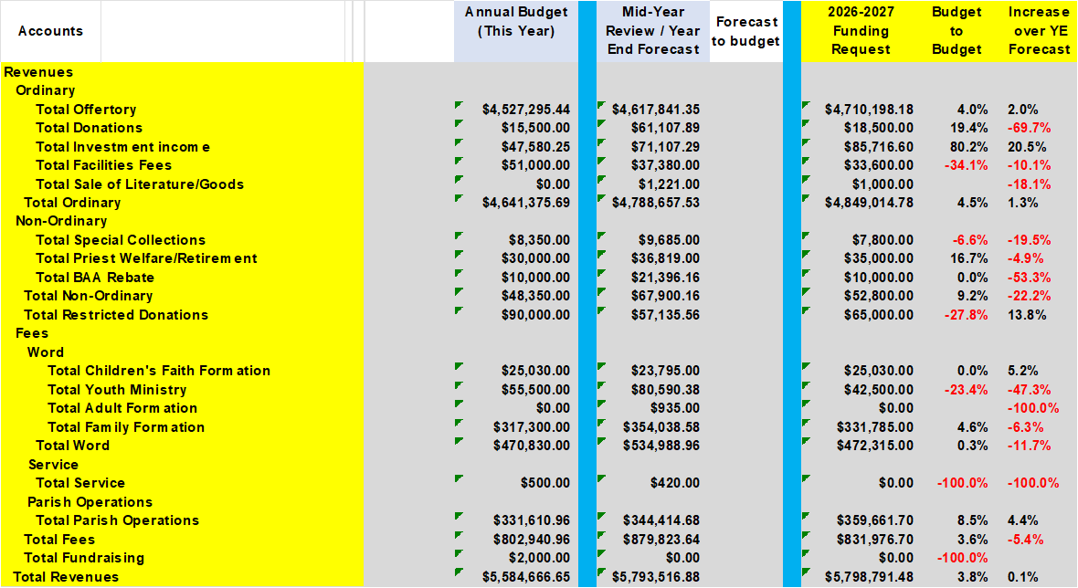

  - Church Expense Summary is shown below:
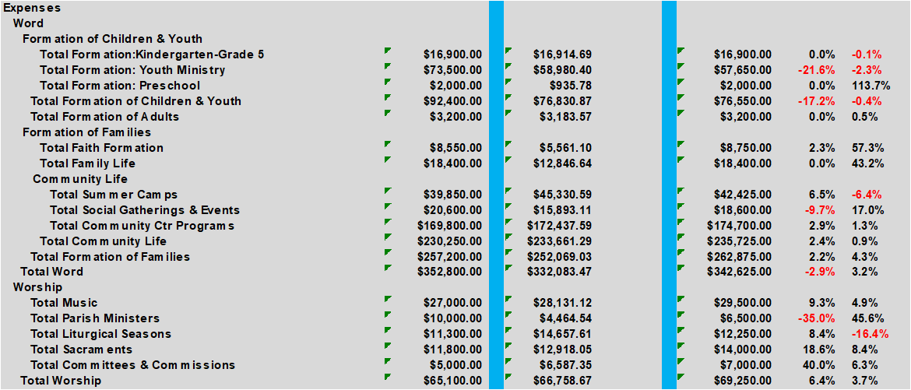

  - Expenses (Continued)
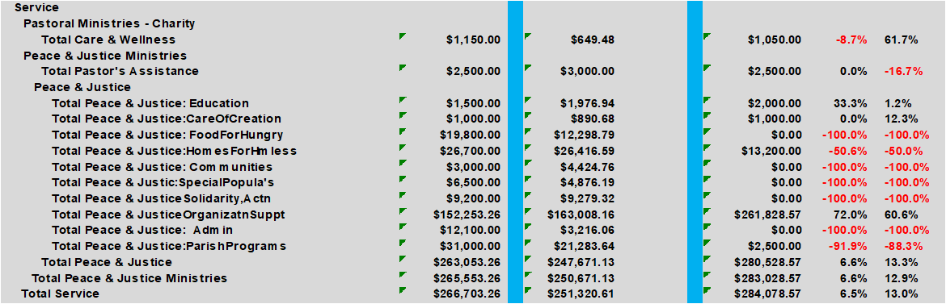

  - Expenses (Continued)
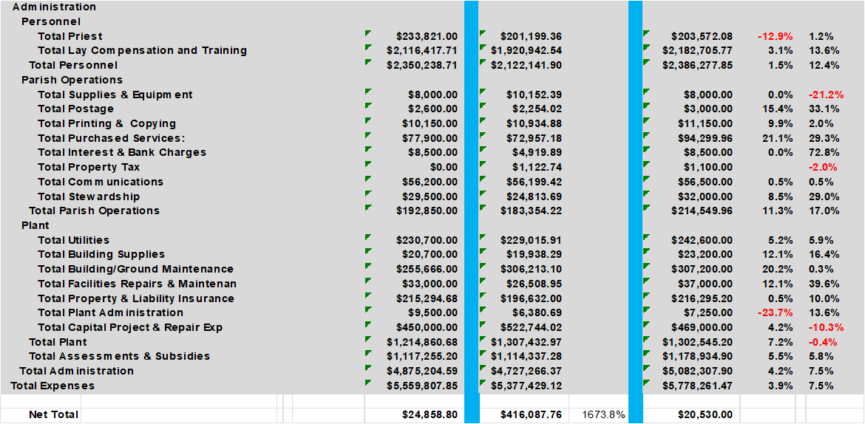

  - Here is a year to year summary of the expenses by areas:

  - Proposed Church 2026-27 Budget Summary:
Revenue $5,798,791
Expense 5,778,261
Net $ 20,530

  - Additional detailed backup charts of the proposed 2026-27 Church budget were provided in the package sent to the Finance Council in Rob Neppel’s note of 5/28/26.
  - Vote Taken – A motion to approve the Church Budget for 2026-27 Fiscal Year as presented, was made and approved.
Columbarium Proposed Budget:
  - Rob Neppel noted the following in the Columbarium budget.
  - Average sales of 4-5 per month, @ 48 to 60 for the year
- Full year at the increased Niche prices
- Budget to Budget Revenue increased $13.9%
  - It is basically, the same budget structure as 2025-2026 with the following changes:
- Administration & Labor increased 4%
- All other expense line items will increase/decrease in proportion to Niche sales.
- Landscaping will remain flat (budget to budget)

  - The budget for the Columbarium is shown here:

Revenue:

Expense:
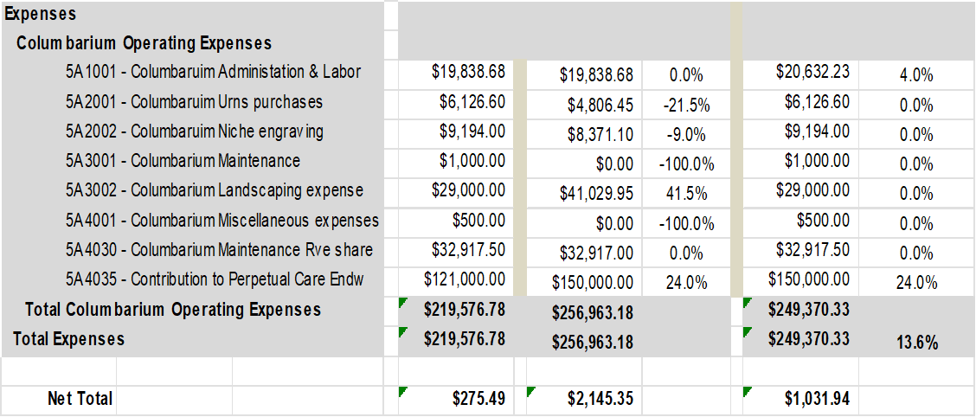
  - Proposed Columbarium 2026-27 Budget Summary:
Revenue $250,402
Expense 249,370
Net $ 1,032

  - Vote Taken – A motion to approve the Columbarium Budget for 2026-27 Fiscal Year as presented, was made and approved.

Offertory Update:
  - Rob Neppel shared that through April, offertory is up $189K from last year at the same time.
This is a 5.1% YTD increase.
  - ParishSOFT eGiving is $19,231 ahead of last year, a 1.9% YTD increase, 218 new families have signed up this year.
  - TipTap is collecting an average of $8,900 per month for this fiscal year and continues to increase month to month.
  - Current forecast is to come in @ $90,000 over our budget target, 4.0% increase
  - Historically:
- 2024-2025 was a 5.3% YTY increase
- 2023-2024 was a 6.2% YTY increase
- 2022-2023 was a 6.2% YTY increase
- 2021-2022 was a 8.7% YTY increase

Closing the Books for 2025-2026:
  - Rob Neppel shared that as reported earlier, all budget areas are on track to close with surpluses.
  - We will execute the following withdrawals:
- $400,000 from Maintenance Reserve to cover approved summer projects.
- $20,688 from the Lay Ministry Education Endowment to cover grants.
  - Final determination for potential additional withdrawals and deposits will be made as we are near the end of June, after our expense cutoff (6/19).
  - Surplus funds which are not required to ensure positive cash flows for June and July will be allocated to the Maintenance and Capital Reserves.
  - Rob also recommended we move the Covid Contingency Funds (@ $390K) into the Capital Reserve savings account. There were no issues raised.

VOTES TAKEN:
  - A motion to approve the Finance Council Meeting Minutes of 4/27/26, was made and approved.
  - A motion to approve the Church Budget for 2026-27 Fiscal Year as presented, was made and approved.
  - A motion to approve the Columbarium Budget for 2026-27 Fiscal Year as presented, was made and approved.

OTHER:
  - Father Chris approved all the recommendations and votes taken during this Council meeting.
  - He discussed some things in the horizon which he hopes will renew the parish spirit. These include more retreats, a trip with the top 20 donors, power of purpose conference and more events in collaboration with the Franciscan University.
FUTURE MEETINGS:
  - Schedule for Fiscal Year 2026-27 Finance Council Meetings – All meetings start at 7:00 p.m. on Mondays.
Monday – August 10, 2026 - Prior year wrap up summary
Monday – October 5, 2026 - Fall / Winter Maintenance Projects
Monday – November 16, 2026 - Approve School Tuition Rates
Monday – January 11, 2027 - Mid-Year Checkpoint
Monday – March 8, 2027 - Spring / Summer Maintenance Projects
Monday – April 26, 2027 - Approve School Budgets
Monday – May 24, 2027 - Approve Church & Columbarium Budgets

