The Catholic Community of
St. Francis of Assisi

Finance Council Minutes
Date: 3/12/24 Time: 7:00 p.m.

Attendance:
Members | Present | Members | Present | Members | Present | Members | Present
Steve Vebber |  | Sarah Hoffman | X | Esperanza Neri | X | Msgr. Michael Clay | X
 |  | Reji John | X | David Nerz | X
Delynn Alexander | X | Steve Joseph |  | Luke O’Rourke | X | Fr. James Singarayar | X
Lachlan Cox | X | Arvie Lacson | X | Clare Pope | X | Mae Villanueva
Graham Dixon | X | Bill Laxton | X | Peter Russo | X
Paul Fedorkowicz | X | Tom Mense |  | Kathy Sales
Heidi Hobler | X | Rob Neppel | X | Dawn Smith | X

AGENDA:
Opening Prayer
Accept Minutes of 1/30/24
School Updates – TFS & Pre-School
Offertory Update
Endowment Update
Mid-Year Budget Review Update
Maintenance Update
Finance Council Charter/By-Laws
Q&A
Meeting Schedule for Fiscal Year 2023-24 and 2024-25
Closing Prayer

OLD BUSINESS:
  - Steve Vebber was unable to attend this meeting. Sarah Hoffman covered for him.
  - Rob Neppel thanked the members for the quick response to his note of 2/26/24, and the approval of $467,050 for two Carrier air-cooled chiller units to replace the Chilling Tower. The Tower provides HVAC services for Siena, Chapel, Community Canter, and Elizabeth Hall. Currently there is a 40-week lead time for equipment delivery.
  - Feedback on the Finance Council Meeting Minutes of 1/30/24 was requested.
  - There were no changes requested.
  - Vote Taken – A motion to approve the Finance Council Meeting Minutes from 1/30/24 was made and approved.

NEW BUSINESS:
School Updates:
TFS Update:
  - Dawn Smith noted that as of the meeting, 470 students have enrolled for the upcoming 2024-25 school year. Returning students have until March 20th to re-enroll and be guaranteed a spot. After this date, offers will be made to people on the waiting list.
  - We are well ahead of where we were at the same time last year. Dawn expects us to be around 672 students next year versus the plan of 665 students.

Pre-School Update:
  - Heidi Hobler noted that as of 3/8/24 we have 171 spots filled for the upcoming school year. Our plan assumes we will have 164. We have capacity for 182. Last year at this time we had 150 registered.
  - The above numbers include the toddler class that was a 1-day class this year and will be 2 days next school year.
  - She also said that a landscape designer has been hired to create a blueprint for our Exploration Station (playground by the front entrance). This will be funded from the proceeds from the Harvest Moon fundraiser.
  - We are currently aware of 1 staff member who will be retiring and one individual who wants to reduce her hours for next year. The staff have until March 15th to announce their intentions.

Offertory Update:
  - Rob Neppel noted that through week 37, we are ahead of last year by $53,385 (2.2%) vs. our budget expectation of 4%.
  - Faith Direct donations are consistently running below last year’s levels. Part of this is due to some older donors shifting toward using their RMD’s (Retirement Minimum Distributions). There are required minimum withdrawals from retirement plans set by the Federal government when people reach the age of 72. RMDs have an impact on our cash flow since these are annual distributions.
  - In each of the last 2 months we have lost 8 families who were using Faith Direct previously.
  - We are currently in the process of analyzing giving over the past three years.
  - Msgr. Clay will be hosting donor receptions in the Rectory for founders and our large donors.

Endowment Update:
  - Rob Neppel showed a chart of Endowment balances for the 4th Quarter ending 12/31/23. Overall, it was a good quarter. For the quarter we were up 8.6% from the prior quarter. The total value of our endowments is $5,042,074. The corpus value of this is $3,115,595.
  - It was noted that the Foundation only provides quarterly statements to us. We will not see the First Quarter results until mid-April.

Mid-Year Budget Reviews:
  - Rob Neppel noted that both TFS and Pre-School are projected to end the year with sufficient funds to carry them through June and July, which is when we have no income coming in.
  - The Columbarium will be fine from a cash flow standpoint. However, as discussed during the last Finance Council meeting, the operational budget will show a significant negative value, due to the transfer of $150,000 to the Contingency Reserve account.
  - The Church budget will be very tight due to Offertory continuing to lag behind budget expectations. The short fall will be partially offset by Other Ordinary and Non-Ordinary income exceeding expectations. Budget owners have been asked to limit their future spending to critical items only. Another review will be conducted in April, after Easter numbers are finalized.

Maintenance Oversight Committee Updates:
  - Rob Neppel noted the Committee met February 8, 2024. He provided a status of where we stand on all the Maintenance projects that were approved for 2023 and 2024.
  - All summer 2023 projects have been completed with the exception of these projects: Security Enhancements (on-going), Parlor Renovation (on-hold), TFS Bell/Communications System (Underway).
  - A status of the Fall/Winter 2023-24 Projects status was also provided:
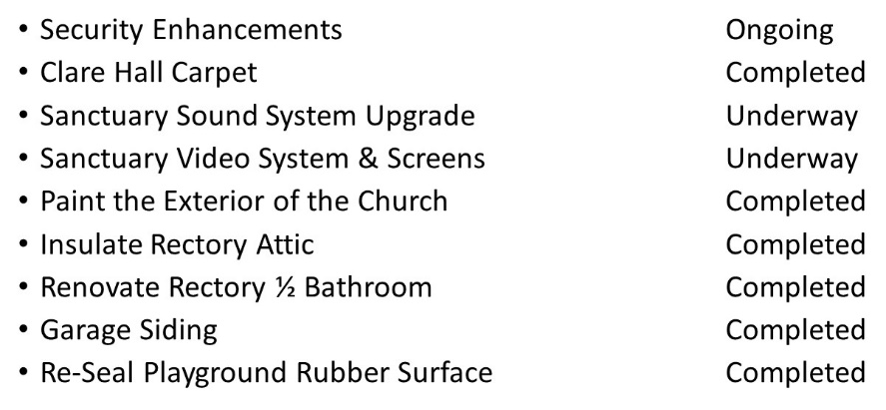
  - Total funds that are outstanding for the above approved projects is $500K.

  - A projection was provided on our Maintenance Reserve Savings Account:
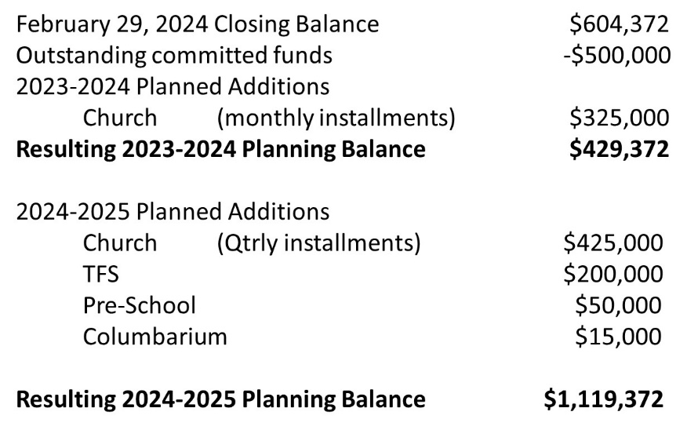
  - In summary, the past 2 years have been very busy with maintenance projects.
  - We expect a number of the major projects will carry over to summer of 2024.
  - We do feel we have healthy reserves to address current and future maintenance needs for this fiscal year.

  - The campus looks attractive and is well maintained. We are keeping up with major projects called out by the Giles Flythe Study. But there are significant projects that are coming this Spring/Summer, these include:
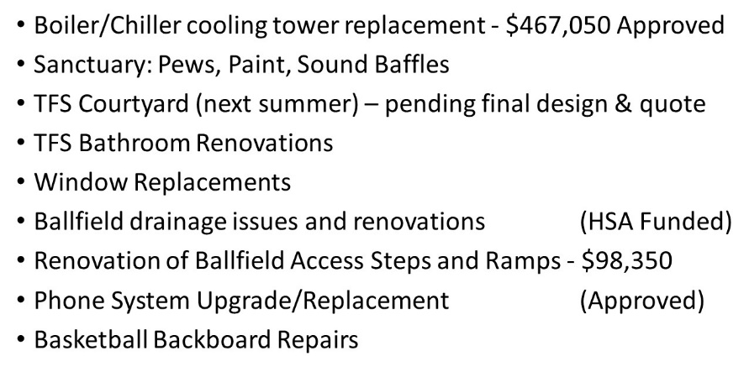

  - In addition to the above, we will have to monitor our aging HVAC Heat Pump systems, water heaters, and appliances. We also have to continue to focus on Security enhancements as our new Director of Security becomes more familiar with our campus and does his evaluation.
  - It was noted that in addition to the Giles Flythe Capital Asset and Reserve Study, the Committee also maintains the St. Francis Maintenance Tracking Spreadsheet. This spreadsheet is a detailed list of Maintenance items that we should look at and when they are coming due for evaluation.
  - Vote Taken – A motion to approve $98,350 in Maintenance Reserve funding for the renovation of the ball field access steps and ramps, was made and approved.

Finance Council Charter / By-Laws Discussion:
  - Msgr. Clay asked if anyone had any additional feedback on the latest draft of the Finance Council Charter / By Laws document (Version 3/5/24 sent out to the members in Rob Neppel’s note of 3/8/24).
  - There was discussion on Article V, Section 4 Internal Controls, item C, specifically what was meant by the annual review and what the role of the Council was here and whether it is more over-sight or is the Council required to conduct a detailed audit of our Finance Department. Peter Russo agreed to re-work and send out his proposed language to the Council members for review.
  - Vote Taken – A motion to approve Version 3/5/24 draft of the Finance Council Charter / By Laws document, contingent on acceptance by the Finance Council members of Peter Russo’s proposed replacement language for Article V, Section 4 Internal Controls, item C, was made and approved.

Discussion:
  - Msgr. Clay and Rob Neppel noted to the Council that at today’s Directors Meeting it was decided that we insert a financial update into our weekly bulletin. This would be more than just a section with numbers, but something that will provide context as well. Rob said he will develop a template and review this with members.
  - Rob also noted that the Diocese has been pushing for one financial, membership and scheduling system for all the Diocese churches and schools. What was initially an optional migration, soon could become mandatory for all within 2 to 3 years based on what Msgr. Clay heard at the latest Priest Council Meeting. We currently have no plans to migrate away from our ACS system since we see no benefits in the new system, and also since this would require massive manhours to implement, but we may have no choice. Rob will keep you apprised of any announcements on this.

VOTES TAKEN:
  - A motion to approve the Finance Council Meeting Minutes from 1/30/24 was made and approved.
  - A motion to approve $98,350 in Maintenance Reserve funding for the renovation of the ball field access steps and ramps, was made and approved.
  - A motion to approve Version 3/5/24 draft of the Finance Council Charter / By Laws document, contingent on acceptance by the Finance Council members of Peter Russo’s proposed replacement language for Article V, Section 4 Internal Controls, item C, was made and approved.

OTHER:
  - Msgr. Clay provided his approval and acceptance of all recommendations and votes taken during this meeting.

FUTURE MEETINGS:
  - Schedule for 2023-24 Finance Council Meetings – All meetings start at 7:00 p.m. on Tuesdays.
April 30, 2024 – Approval of School Budgets for 2024-25
May 28, 2024 – Approval of Church & Columbarium Budgets for 2024-25

  - Schedule for 2024-25 Finance Council Meetings – All meetings start at 7:00 p.m. on Tuesdays.
August 13, 2024 - Prior year wrap up summary
October 15, 2024 - Fall / Winter Maintenance Projects
November 19, 2024 - Approve School Tuition Rates
January 14, 2025 - Mid-Year Checkpoint
March 11, 2025 - Spring / Summer Maintenance Projects
April 29, 2025 - Approve School Budgets
May 27, 2025 - Approve Church & Columbarium Budgets

